PHONE STORE RECORD

PROGRAM-1

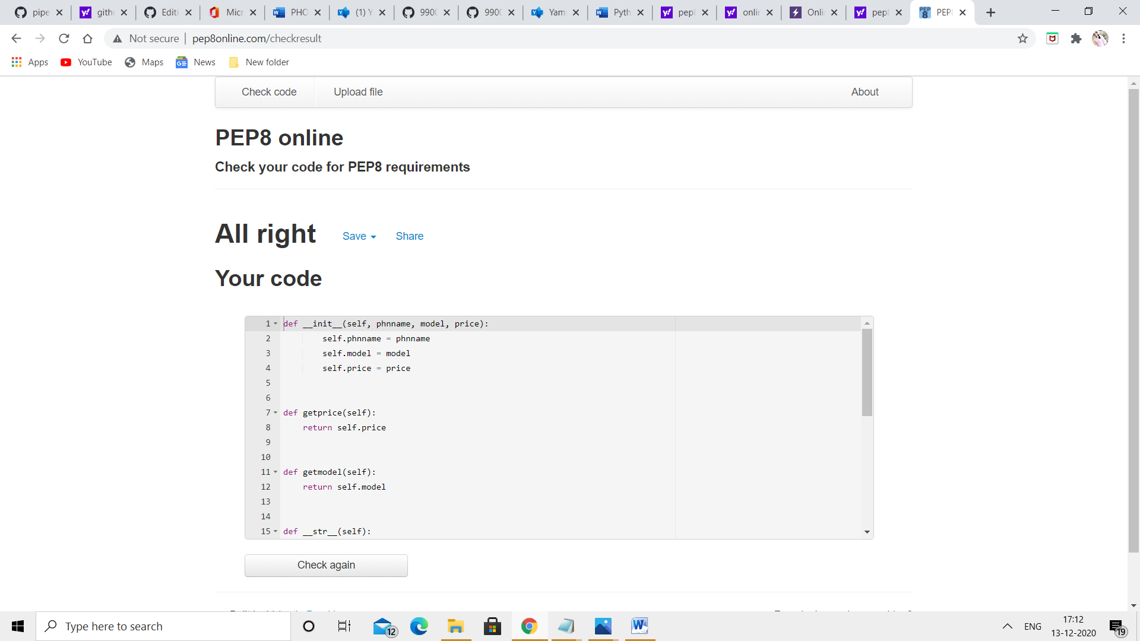

PROGRAM-2

